Breadth First Search (BFS)
Aim:
To traverse a graph using BFS.
Objective:
To visit nodes level by level.
Algorithm:
- Start from source node.
- Add node to queue.
- Visit adjacent nodes.
- Repeat until queue becomes empty.
Flowchart:
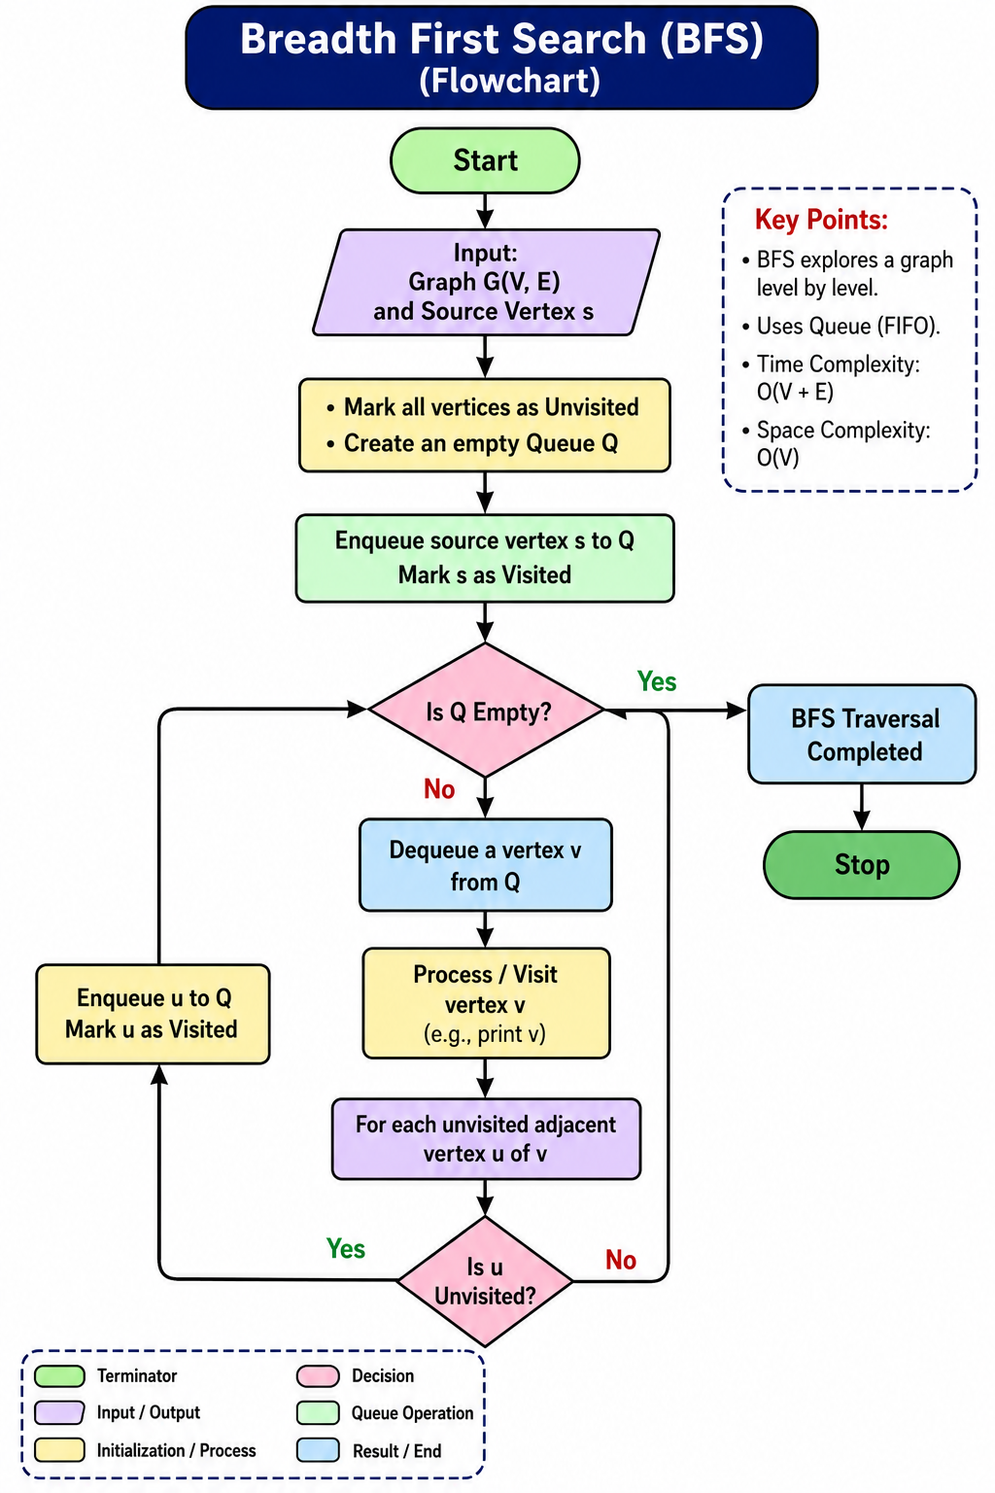

Python code:
graph = {}

n = int(input("Enter number of nodes: "))

for i in range(n):
node = input("Enter node name: ")
neighbors = input(f"Enter neighbors of {node} (space-separated): ").split()
graph[node] = neighbors

start = input("Enter starting node: ")

visited = []
queue = [start]

while queue:
node = queue.pop(0)

if node not in visited:
visited.append(node)
queue.extend(graph[node])

print("BFS Traversal:", visited)
output: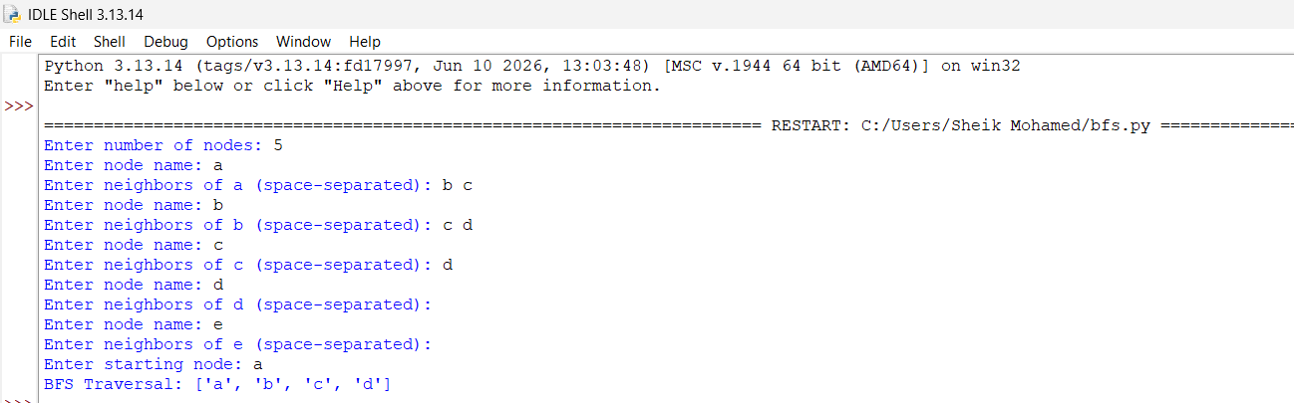
Result:
Graph traversed successfully.
Conclusion:
BFS visits nodes level by level.

